LAB 3


1- Write a program that takes the place of the player (1, 2 or 3) and print the medal he/she win.

Examples:
Input: 1 Input: 2 Input: 3 Input: 4
Output: Gold medal Output: Silver medal Output: Bronze medal Output:



2- Write a program that takes two integers from the user and determines whether they are equal or not.

Examples:
Input: 6 6 Input: 4 6
Output: Yes Output: No

3- Write a program that takes an integer from the user and then determines it can be exactly divided by 7, or not.

Examples:
Input: 22 Input: 35 Input: 700
Output: False Output: True Output: True

4- Write a program that takes the age of the user and determines whether he/she can vote or not.


Note: A person should be at least 18 years old to vote.

Examples:
Input: 20 Input: 15
Output: You can vote Output: You can’t vote

5- Write a program that takes three angles of a triangle from the user and checks whether the triangle is valid or not.
A triangle is valid if the sum of all the three angles is equal to 180 degrees.
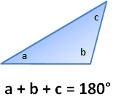
Examples:
Input: 120 30 30 Input: 90 45 40
Output: Triangle Output: Not Triangle

6- Write a program that determines whether given number is a negative even number or not.

Examples:
Input: -8 Input: 8 Input: -7
Output: Yes Output: No Output: No


7- Write a program that takes the user's GPA and prints whether the student is on the dean's list (3.5 to 4.0) or honor roll (3.0 to 3.5).

Examples:
Input: 3.1 Input: 3.6 Input: 2.2
Output: honor roll Output: dean’s list Output:


8- Write a program that takes three integer values x, y, and z from the user, then prints true if the values are strictly ascending or descending (x < y < z or x > y > z), and false otherwise.

9- Write a program that prints the message according to given letter grade.

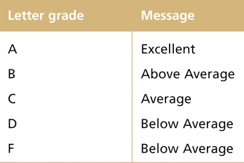

Examples:
Input: A Input: D
Output: Excellent Output: Below Average

